Chapter 1: Introduction to Child Development

Chapter Objectives
After this chapter, you should be able to:
- Describe the principles that underlie development.
- Differentiate periods of human development.
- Evaluate issues in development.
- Distinguish the different methods of research.
- Explain what a theory is.
- Compare and contrast different theories of child development.

Introduction
Welcome to Child Growth and Development. This text is a presentation of how and why children grow, develop, and learn.
We will look at how we change physically over time from conception through adolescence. We examine cognitive change, or how our ability to think and remember changes over the first 20 years or so of life. And we will look at how our emotions, psychological state, and social relationships change throughout childhood and adolescence.

Principles of Development
There are several underlying principles of development to keep in mind:
- Development is lifelong and change is apparent across the lifespan (although this text ends with adolescence). And early experiences affect later development.
- Development is multidirectional. We show gains in some areas of development, while showing loss in other areas.
- Development is multidimensional. We change across three general domains/dimensions: physical, cognitive, and social and emotional.
- The physical domain includes changes in height and weight, changes in gross and fine motor skills, sensory capabilities, the nervous system, as well as the propensity for disease and illness.
- The cognitive domain encompasses the changes in intelligence, wisdom, perception, problem-solving, memory, and language.
- The social and emotional domain (also referred to as psychosocial) focuses on changes in emotion, self-perception, and interpersonal relationships with families, peers, and friends.
All three domains influence each other. It is also important to note that a change in one domain may cascade and prompt changes in the other domains.
- Development is characterized by plasticity, which is our ability to change and that many of our characteristics are malleable. Early experiences are important, but children are remarkably resilient (able to overcome adversity).
- Development is multicontextual. We are influenced by both nature (genetics) and nurture (the environment) - when and where we live and our actions, beliefs, and values are a response to circumstances surrounding us. The key here is to understand that behaviors, motivations, emotions, and choices are all part of a bigger picture.
Now let’s look at a framework for examining development.

Periods of Development
Think about what periods of development that you think a course on Child Development would address. How many stages are on your list? Perhaps you have three: infancy, childhood, and teenagers. Developmentalists (those that study development) break this part of the life span into these five stages as follows:
- Prenatal Development (conception through birth)
- Infancy and Toddlerhood (birth through two years)
- Early Childhood (3 to 5 years)
- Middle Childhood (6 to 11 years)
- Adolescence (12 years to adulthood)
This list reflects unique aspects of the various stages of childhood and adolescence that will be explored in this book. So while both an 8 month old and an 8 year old are considered children, they have very different motor abilities, social relationships, and cognitive skills. Their nutritional needs are different and their primary psychological concerns are also distinctive.

Prenatal Development
Conception occurs and development begins. All of the major structures of the body are forming and the health of the mother is of primary concern. Understanding nutrition, teratogens (or environmental factors that can lead to birth defects), and labor and delivery are primary concerns.
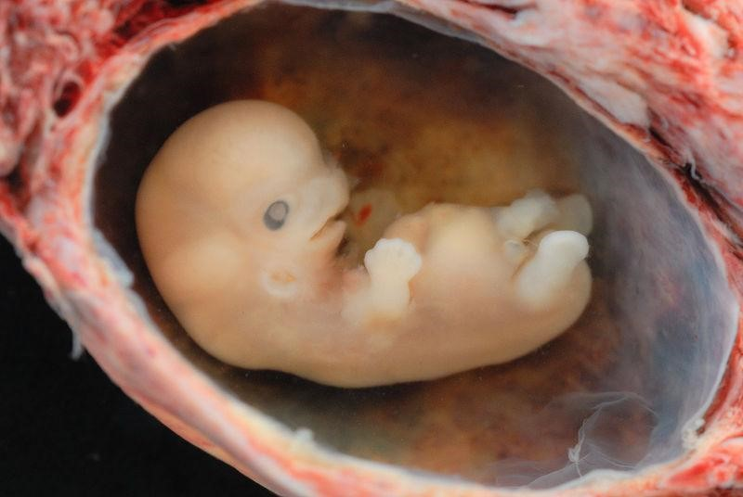
Figure 1.1 - A tiny embryo depicting some development of arms and legs, as well as facial features that are starting to show.

Infancy and Toddlerhood
The two years of life are ones of dramatic growth and change. A newborn, with a keen sense of hearing but very poor vision is transformed into a walking, talking toddler within a relatively short period of time. Caregivers are also transformed from someone who manages feeding and sleep schedules to a constantly moving guide and safety inspector for a mobile, energetic child.
Figure 1.2 - A swaddled newborn.

Early Childhood
Early childhood is also referred to as the preschool years and consists of the years which follow toddlerhood and precede formal schooling. As a three to five-year-old, the child is busy learning language, is gaining a sense of self and greater independence, and is beginning to learn the workings of the physical world. This knowledge does not come quickly, however, and preschoolers may initially have interesting conceptions of size, time, space and distance such as fearing that they may go down the drain if they sit at the front of the bathtub or by demonstrating how long something will take by holding out their two index fingers several inches apart. A toddler’s fierce determination to do something may give way to a four-yearold’s sense of guilt for action that brings the disapproval of others.
Figure 1.3 - Two young children playing in the Singapore Botanic Gardens⁶

Middle Childhood
The ages of six through eleven comprise middle childhood and much of what children experience at this age is connected to their involvement in the early grades of school. Now the world becomes one of learning and testing new academic skills and by assessing one’s abilities and accomplishments by making comparisons between self and others. Schools compare students and make these comparisons public through team sports, test scores, and other forms of recognition. Growth rates slow down and children are able to refine their motor skills at this point in life. And children begin to learn about social relationships beyond the family through interaction with friends and fellow students.
Figure 1.4- Two children running down the street in Carnage, Trinidad and Tobago
⁶Image by Alaric Sim on Unsplash
⁷Wayne Lee-Sing on Unsplash

Adolescence
Adolescence is a period of dramatic physical change marked by an overall physical growth spurt and sexual maturation, known as puberty. It is also a time of cognitive change as the adolescent begins to think of new possibilities and to consider abstract concepts such as love, fear, and freedom. Ironically, adolescents have a sense of invincibility that puts them at greater risk of dying from accidents or contracting sexually transmitted infections that can have lifelong consequences.
Figure 1.5 - Two smiling teenage women.
There are some aspects of development that have been hotly debated. Let’s explore these.

Issues in Development

Nature and Nurture
Why are people the way they are? Are features such as height, weight, personality, being diabetic, etc. the result of heredity or environmental factors-or both? For decades, scholars have carried on the "nature/nurture" debate. For any particular feature, those on the side of Nature would argue that heredity plays the most important role in bringing about that feature. Those on the side of Nurture would argue that one's environment is most significant in shaping the way we are. This debate continues in all aspects of human development, and most scholars agree that there is a constant interplay between the two forces. It is difficult to isolate the root of any single behavior as a result solely of nature or nurture.

Continuity versus Discontinuity
Is human development best characterized as a slow, gradual process, or is it best viewed as one of more abrupt change? The answer to that question often depends on which developmental theorist you ask and what topic is being studied. The theories of Freud, Erikson, Piaget, and Kohlberg are called stage theories. Stage theories or discontinuous development assume that developmental change often occurs in distinct stages that are qualitatively different from each other, and in a set, universal sequence. At each stage of development, children and adults have different qualities and characteristics. Thus, stage theorists assume development is more discontinuous. Others, such as the behaviorists, Vygotsky, and information processing theorists, assume development is a more slow and gradual process known as continuous development. For instance, they would see the adult as not possessing new skills, but more advanced skills that were already present in some form in the child. Brain development and environmental experiences contribute to the acquisition of more developed skills.
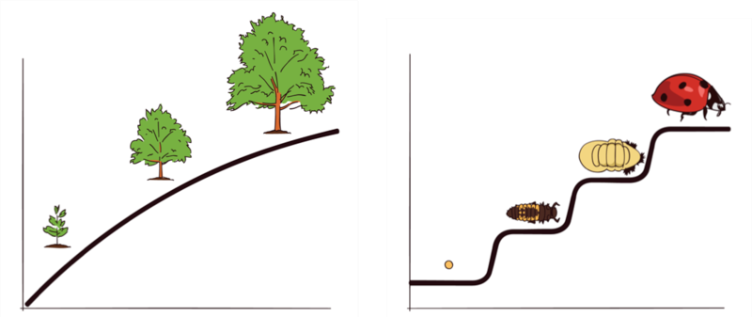
Figure 1.6 – The graph to the left shows three stages in the continuous growth of a tree. The graph to the right shows four distinct stages of development in the life cycle of a ladybug.

Active versus Passive
How much do you play a role in your own developmental path? Are you at the whim of your genetic inheritance or the environment that surrounds you? Some theorists see humans as playing a much more active role in their own development. Piaget, for instance believed that children actively explore their world and construct new ways of thinking to explain the things they experience. In contrast, many behaviorists view humans as being more passive in the developmental process.
How do we know so much about how we grow, develop, and learn? Let’s look at how that data is gathered through research

Research Methods
An important part of learning any science is having a basic knowledge of the techniques used in gathering information. The hallmark of scientific investigation is that of following a set of procedures designed to keep questioning or skepticism alive while describing, explaining, or

testing any phenomenon. Some people are hesitant to trust academicians or researchers because they always seem to change their story. That, however, is exactly what science is all about; it involves continuously renewing our understanding of the subjects in question and an ongoing investigation of how and why events occur. Science is a vehicle for going on a never-ending journey. In the area of development, we have seen changes in recommendations for nutrition, in explanations of psychological states as people age, and in parenting advice. So think of learning about human development as a lifelong endeavor.

Table 1.1 - Advantages and Disadvantages of Different Research Designs
Type of Research Design | Advantages | Disadvantages
Longitudinal | Examines changes within individuals over time Provides a developmental analysis | Expensive  Takes a long time  Participant attrition  Possibility of practice effects  Cannot examine cohort effects
Cross-sectional | Examines changes between participants of different ages at the same point in time Provides information on age-related change | Cannot examine change over time  Cannot examine cohort effects
Sequential | Examines changes within individuals over time  Examines changes between participants of different ages at the same point in time  Can be used to examine cohort effects | May be expensive  Possibility of practice effects

Introduction to Lifespan, Growth and Development by Lumen Learning is licensed under CC BY 4.0
Lifespan Development: A Psychological Perspective by Martha Lally and Suzanne Valentine-French is licensed under CC BY-NC-SA 3.0 (modified by Jennifer Paris)
Introduction to Lifespan, Growth and Development by Lumen Learning is licensed under CC BY 4.0
Image by lunar caustic is licensed under CC BY 2.0
Han Myo Htwe on Unsplash
Periods of Development by Lumen Learning is licensed under CC BY 4.0
Matheus Ferrero on Unsplash
Image by NOBA is licensed under CC BY-NC-SA 4.0
Lifespan Development: A Psychological Perspective by Martha Lally and Suzanne Valentine-French is licensed under CC BY-NC-SA 3.0

